COVID-19
Update: 02.03.2020
If you are having difficulty breathing, shortness of breath or chest pains, call 111
COVID-19 (also known as the novel coronavirus that has been in the news since the start of 2020) is now in New Zealand. So far there has been one confirmed case, but we are expecting to see more cases soon.
There has been a confirmed contact (of the person diagnosed with COVID-19) who has travelled to Nelson and the Public Health department are in the process of tracing that person and getting them to self-isolate.

Key Points
- Main symptoms of COVID-19 are flu-like illness, fever and cough
- It is mainly affecting older people with other medical conditions, mostly those with cardiovascular diseases (previous heart attacks, high blood pressure or other heart conditions like heart failure) and diabetes. But anyone can get COVID-19
- Contagion period (the time it takes from your exposure to the virus until you show signs of having the virus) is estimated to be between 2-10 days (WHO, 2020)
- Any person who has travelled outside of the South Island or had overseas visitors stay with them who has symptoms of flu-like illness, fever and cough may have COVID-19
- Close contact (in this instance) is any situation where you are face-to-face with someone closer than 1 metre from them for over 15 minutes or over 2 hours in the same room more than one metre away

What to do if you think you have COVID-19
- Call the helpline number: 0800 358 5453
- If you need medical help or advice, call us on 548 8663 and tell the receptionist that you think you may have COVID-19 or the coronavirus. PLEASE DO NOT WALK IN TO THE MEDICAL CENTRE, CALL AHEAD AND WE MAY ASK YOU TO WAIT IN THE CAR AND MEDICAL STAFF WILL ASSESS YOU THERE.
- We have an isolation room prepared. Outside the main door are masks to wear, please put one on and come inside. We ask that you stand at least 1 metre away from the reception desk. This is to protect our staff and other patients
How does it spread?
- COVID-19 is spread by droplets
- When someone coughs, sneezes or talks, droplets are projected from their mouth and nose. These are heavy and fall onto surfaces. Large droplets with large amounts of virus don’t travel that far (around 1-2 metres) and fall quickly. Smaller droplets with less amount of virus travel further and fall slower. See figure 1 below
- If you touch a surface which has droplets on it and then touch your mouth, nose or eyes, the virus can enter your body
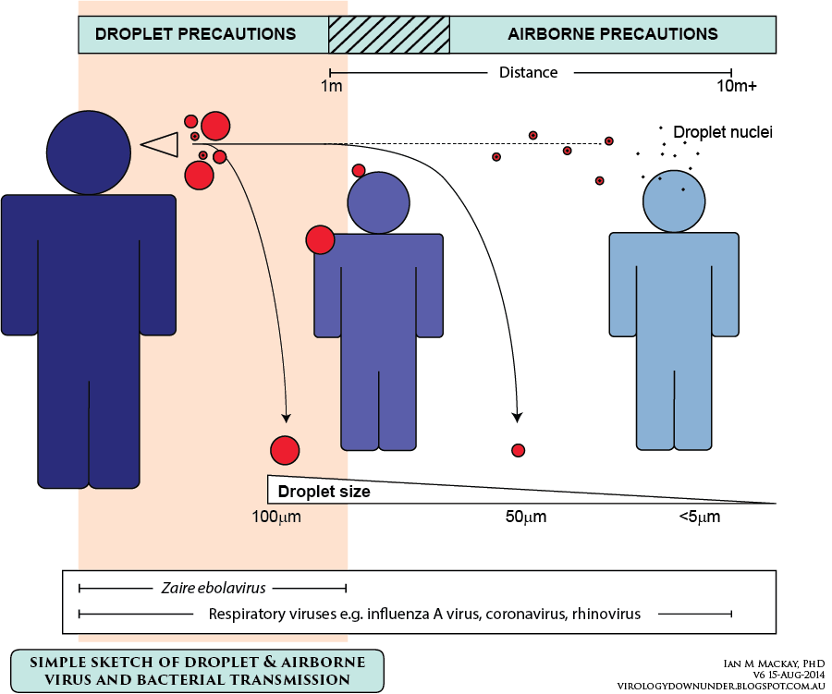
How can you limit your risk of getting COVID-19?
- Cover all coughs and sneezes with a tissue (then throw it away) or into your sleeve of your elbow
- Immediately use hand sanitizer (70% alcohol is best) or wash your hands for at least 20 seconds with soap and water and dry them so no moisture is left
- Try to remain more than 1 metre away from people who are coughing or sneezing
- Avoid touching your mouth, nose of eyes with unwashed hands as much as you can
- Stay at home if you are sick
- Clean all surfaces with disinfectant

What is self-isolation?

- Self-isolation means staying away from situations where you could infect other people
- This means any situation where you may come in close contact with others
- If you are a visitor to New Zealand, this means you should avoid sitting in a restaurant, or participating in any type of tour group
- If you are unsure if you should be self-isolating, or if you do not know where you can go, please contact Healthline for free on 0800 358 5453.

Living with others
- As much as possible, you should limit your contact with people other than the family members/companions you travelled with. You should avoid having visitors to your home, but it is okay for friends, family or delivery drivers to drop off food
- If you are in a home where the other residents have not travelled (eg, your home / flat, a homestay, student accommodation), keep close contact with the other residents to a minimum by avoiding situations where you may have face-to-face contact closer than 1 metre for more than 15 minutes
- You should not share dishes, drinking glasses, cups, eating utensils, towels, pillows or other items with other people in your home. After using these items, you should wash them thoroughly with soap and water, place them in the dishwasher for cleaning or wash them in your washing machine.
- Cover your coughs and sneezes
- Wash your hands
- Transport - You may need to travel across New Zealand to your accommodation, for example, by plane, train or bus. Where possible, sit in a window seat in a row by yourself. If you are unwell you should seek advice from Healthline before you travel. While travelling make sure you use hand sanitiser regularly. If you need to cough or sneeze, cover your mouth or nose, or you can cough and sneeze into your sleeve. You should minimise your use of public transport, taxis and ride-sharing apps like Uber. Avoid crowded public transport, especially during rush hour.

Ministry of Health COVID-19 Helpline: 0800 358 5453

